
Design Optimization Proposal for Enhanced
Robotic Arm Responsiveness

1. Problem Statement
Identified Issues:
- Actuator Strain:
  - Description: The baseline simulation uses a 0.20-second actuator response and a durability score of 75/100, indicating room to improve motion efficiency and structural endurance.
  - Impact: Slower actuation can reduce responsiveness, while limited durability may increase wear during repeated operating cycles.
- Sensor Misalignment:
  - Description: Sensor alignment was not measured directly in the supplied simulation. It remains a design consideration because an offset sensor can provide inaccurate position feedback.
  - Impact: Inaccurate feedback can require corrective movement, reducing positional precision and potentially adding control-loop delay.

2. Proposed Modifications
Modification 1:
- Proposal: Apply a 0.50 actuator-efficiency factor through a higher-efficiency actuator and optimized drive settings.
- Justification: The simulation estimates that this modification reduces response time from 0.20 seconds to 0.10 seconds, a 50% improvement.
Modification 2:
- Proposal: Realign the position sensor and reinforce its mounting structure using a 0.10 reinforcement factor.
- Justification: A stable, reinforced mount can help preserve alignment, while the model estimates a durability increase from 75 to 82.5.

3. Simulation Results
- Initial Metrics:
  - Actuator Response Time: 0.20 seconds
  - Sensor Feedback Delay: Not measured in the supplied simulation
- Post-Optimization Metrics:
  - Actuator Response Time: 0.10 seconds
  - Sensor Feedback Delay: Not measured; requires a dedicated sensor test
- Key Insights:
  - A 0.50 efficiency factor produced a modeled 50% response-time reduction, and a 0.10 reinforcement factor produced a modeled 10% durability increase. The two factors are independent in this simplified simulation, so no responsiveness-versus-durability trade-off was modeled.

4. Annotated Visual Examples
Visual Example 1: Current Sensor Misalignment vs. Proposed Realignment
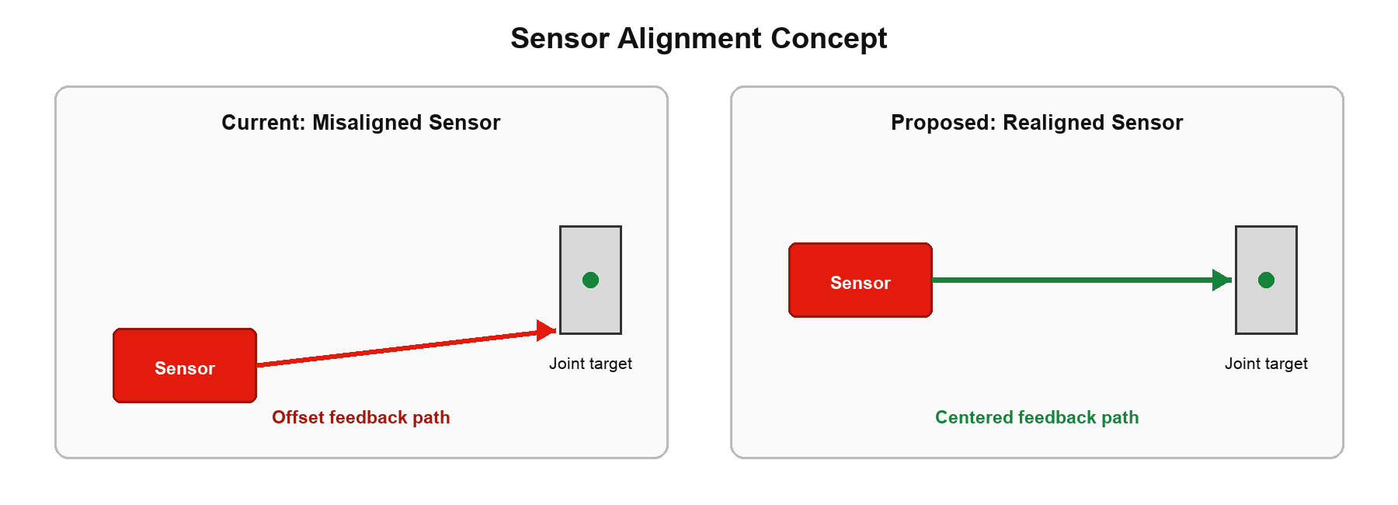
- Brief Description: Conceptual comparison showing an offset feedback path before realignment and a centered path after realignment. This is a proposed design change, not a measured sensor-delay result.
Visual Example 2: Actuator Upgrade Impact
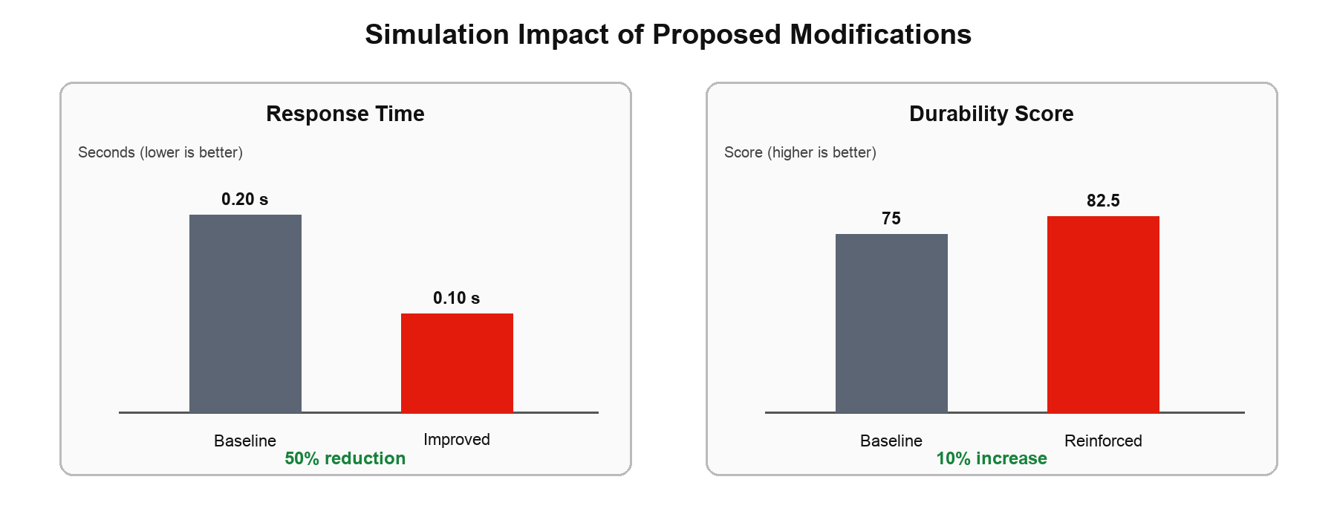
- Brief Description: The simulation estimates response time falling from 0.20 to 0.10 seconds and durability increasing from 75 to 82.5.

5. Expected Outcomes
- Improved Responsiveness: Modeled actuator response time decreases by 50%, from 0.20 to 0.10 seconds.
- Enhanced Reliability: A reinforced, realigned sensor mount is expected to support more consistent feedback; physical testing is required to quantify the benefit.
- Increased Durability: The 0.10 reinforcement factor raises the modeled durability score by 10%, from 75 to 82.5.

6. Conclusion
Summarize the impact of your proposed modifications:
- The model estimates faster response (0.20 to 0.10 seconds) and higher durability (75 to 82.5). Next, validate actuator and sensor behavior with repeated hardware-in-the-loop tests, since sensor delay was not simulated.

